# Data 245 - Machine Learning Fall, 2022

*Project Report*

**AIRBNB SENTIMENT AND RECOMMENDATION SYSTEM**



Group - 7

**Table of contents**

1. **Abstract 3**
2. **Introduction 3**
3. **Problem Statement 4**
   1. Project background 4
   2. Literature survey 4
4. **CRISP-DM Approach**
5. **Data Collection** **7**
6. **Exploratory Data Analysis (EDA) 9**
   1. Data Exploration 9
   2. Data Transformation 14
   3. Text Preprocessing 16
   4. Data Preparation 19
   5. CountVectorizing 19
   6. Preparing the data for the model 21
      1. Modeling using CountVectorizer 21
      2. Modeling using TF-IDF vectorizer 22

5.6.3. Comparison of CountVectorizer vs TF-IDF 24

1. **Model selection 25**
   1. Models implemented 25
   2. Training model and results 30
2. **Recommendation**32
3. **Deployment 32**
4. **Source Code Link 34**
5. **Conclusion 35**

**References 36**

# Abstract

As the world recovers from covid-19 the travel industry has started booming again. Reviews play a major hand for customers while booking any hotels. According to (Bridges, 2022) 70.9 percent of people agreed upon being influenced by online reviews. For this project we have used Airbnb dataset to perform sentiment analysis of reviews and develop a machine learning model to classify sentiments of the reviews and based on that we have deployed a recommendation system. Recommendation system is based on a recommendation algorithm designed by us, which takes the sentiment score of reviews and several other factors into account. A web page where users can enter their preferences and the output will be recommendations of the top 5 hotels that match their interest.

# Introduction

For this project we have used Airbnb data set to produce recommendations based on user reviews. It will make hotel selection for the customers really easy as the recommendations will be based on user reviews. Moreover, Business suppliers and investors will benefit from being able to better comprehend client feedback and make the required adjustments to advance their enterprises and increase profits.

Objectives:

* + Airbnb data web scraping using Apify API.
  + Perform Data exploration to comprehend the dataset
  + Clean the data as per appropriate models.
  + Implement NLP models – Textblob, Vader and Flair to classify the reviews.
  + Process the reviews using CountVectorizer and TF-IDF for machine Learning Models
  + Implement Machine Learning models to classify the reviews.
  + Evaluate the models
  + Pick the best performing model and dump it into a Pickle file.
  + Deploy a recommendation system based on the reviews and user preferences.
  + Develop a Web application where users can get recommendations and hotel owners can check sentiments of the reviews of their hotel

# Problem Statement

* 1. Project background

Reviews can be considered one the most trusted source of information as most of the people go through the reviews first before booking any hotel. Hence, with this project our goal was to utilize this information. Furthermore, we have tried to quantify this information in order to make a recommendation system. With the help of these reviews from Airbnb dataset we have tried to predict better recommendations for the user while keeping their preferences in mind.

* 1. Literature survey

According to research by Sharma et al. (2015) utilized TripAdvisor and Booking.com datasets to develop a multi criteria review based hotel recommendation system. The Trip Advisor dataset was used in this study, and several characteristics were retrieved in order to create an item x feature matrix. Stanford Core NLP Library, Aggregation based collaborative filtering were the models and methods used. Model had 64% accuracy with precisions of 77% and error of 36%.

Hu et al. (2016) conducted a research on hotel recommendation system based on review and context information. This study proposes a context-aware personalized hotel (CAPH)

recommendation system which extracts representative terms in the reviews and corporates into the user-matrix. The proposed CAPH approach was tested with UCF and IC. CAPH_ICF’s - method achieves higher accuracy MAE value (Friends: 0.435 and Solo: 0.234)

In the work of Fang & Zhan (2015), machine learning algorithms were utilized to perform sentiment analysis for Amazon product reviews. Machine learning models including Naive Bayes, Random Forest, and SVM were used for testing data. Random Forest performs best for sentence level categorization while SVM and Naive Bayes perform better for review level categorization.

Bauman et al. (2017) study presents recommending Items with the Most Valuable Aspects Based on User Reviews. The study proposes Sentiment Utility Logistic Model(SULM) , an aspect-level sentiment analysis that automatically recognizes elements and associated feelings specified by users in their evaluations. They have also used LRPPM, Hidden Factors as Topics (HFT), Linear Regression, Stochastic gradient descent methods. SULM outperformed the LRPPM and HFT

# CRISP-DM Approach

For this project, we have adopted the CRISP-DM (The Cross Industry Standard Process for Data Mining) methodology.

1.Business Understanding:

Hotel reviews are trusted by most of the customers in the travel industry hence, we have tried to understand the reviews and determine the sentiments of the reviews. As for this project the primary focus is on the positive reviews which can be used in the recommendation system according to the preferences, location, budget, etc entered by the customer.

2.Data Understanding:

In this phase according to the needs of the project and our goals, we collected, analyzed and cleaned the data accordingly.

2.1. Data Collection:

As far as the data collection goes the dataset was scraped from Airbnb which has the data of the listings on Airbnb site.

2.2. Data Exploration:

We performed exploratory data analysis on the data set in order to get a feel of the datasets, discover some patterns and insights. To get an idea how the dataset is distributed, to check for nulls, outliers, redundancies, inconsistencies, etc.

2.3. Data Preparation:

As part of data preparation, we did steps mentioned below:

1. Data preprocessing: The data scraped from the hotel had a maximum 50 reviews of 1500 hotels pan California containing 1252 columns. It had many unnecessary columns such as urls and geo locations. These columns were removed.
2. Data processing: The review column was a dictionary containing reviews and many other unnecessary features. We selected main features such as hotel name, location, stars, guests ,comments, ratings of each comment etc. and our final DataFrame shrunk down from 1252 columns to 10 columns.
3. Data preparation: We observed that only three columns had missing values. So we treated those columns.
4. Data preprocessing: We cleaned the comments by removing HTML tags and numbers,multiple spaces etc. for NLP models. We further cleaned the comments by Tokenization, stop words removal and lemmatization for feeding them through CountVectorizer and TF_IDF to vectorize the comments to be fed into a machine learning model.
5. NLP development: We labeled our Dataset using ratings for each review. We segregated 4 and 5 ratings to be positive sentiment(1) and below 4 as negative sentiment(0).We modeled our comments using TextBlob, Vader and Flair and classified them according to the scores received for each comment by the model. We then evaluated the models using evaluation metrics.
6. ML Models: We implemented Naïve Bayes,Logistic Regression,Random Forest,KNN,Decision Trees,Bagging,XGboost,Adaboosting for classification of our comments.
7. Evaluation: Finally, we evaluated the model performance.
8. Deployment: Best model was picked using the pickle file and later used by recommendation system to give the top 5 hotels according to user preference.

Figure 2 shows all the tools, libraries, and environment used to deploy the machine learning model and demo.

**System Architecture**

System architecture of our project can be referred to from Figure 2. Firstly, the data was scraped from Airbnb.com using Apify. Apify is an automated web scraping tool which is easy to use and it provides access to data in a variety of forms. After that Data cleaning and Exploratory data analysis was performed. All the essential data cleaning steps were performed such as handling null values, redundancy, inconsistencies, outliers, etc. Dropped all the columns which irrelevant to the goal of the project

After that data transformation was performed, Data labeling was done where we labeled reviews with ratings less than four negative and greater than or equal to four positive. Several other text processing were done where HTML, punctuations, special characters, etc. where removed. Tokenization was done and data augmentation was done to handle the bias in the data towards the positive rated reviews. Finally, the data was split into testing and training with a split ratio of 50/50.

Once the data preparation phase was done model training was started. We trained the model using NLP models such as Textblob, Vader, and Flair. We also wanted to draw comparisons between NLP models and machine learning models hence we also trained models using Randomforest, Logic Regression, and Bayes ML model along with others. After comparing the accuracy of these models,we deployed the best model using a pickle file.

Lastly, we developed a recommendation system which takes user preferences as input and gives top 5 recommendations. These recommendations are made by taking into consideration the user preferences, hotel name, address, ratings, vectorized review, and reviews' sentiments. Based on these factors the recommendation system gives out top five recommendations. We have also developed a GUI to find the review sentiments of the hotel which can be utilized by the hotel owner themselves or any user which is looking to find information on a particular hotel.

**Figure 2**

***System Architecture***

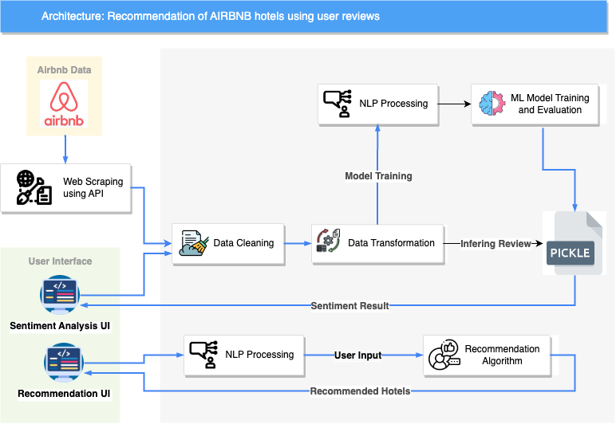

# Data Collection Data was collected for 1500 California based hotels containing a maximum of 50 reviews each from Airbnb.com. Apify API was used to scrap the data as we wanted to get the data of live listings. The data scrapped had 1252 columns.

# 

*Figure 3. Airbnb Hotel Reviews RAW dataset containing 1252 features.*

# 

Figure 4. Airbnb Hotel after extracting 10 useful features.

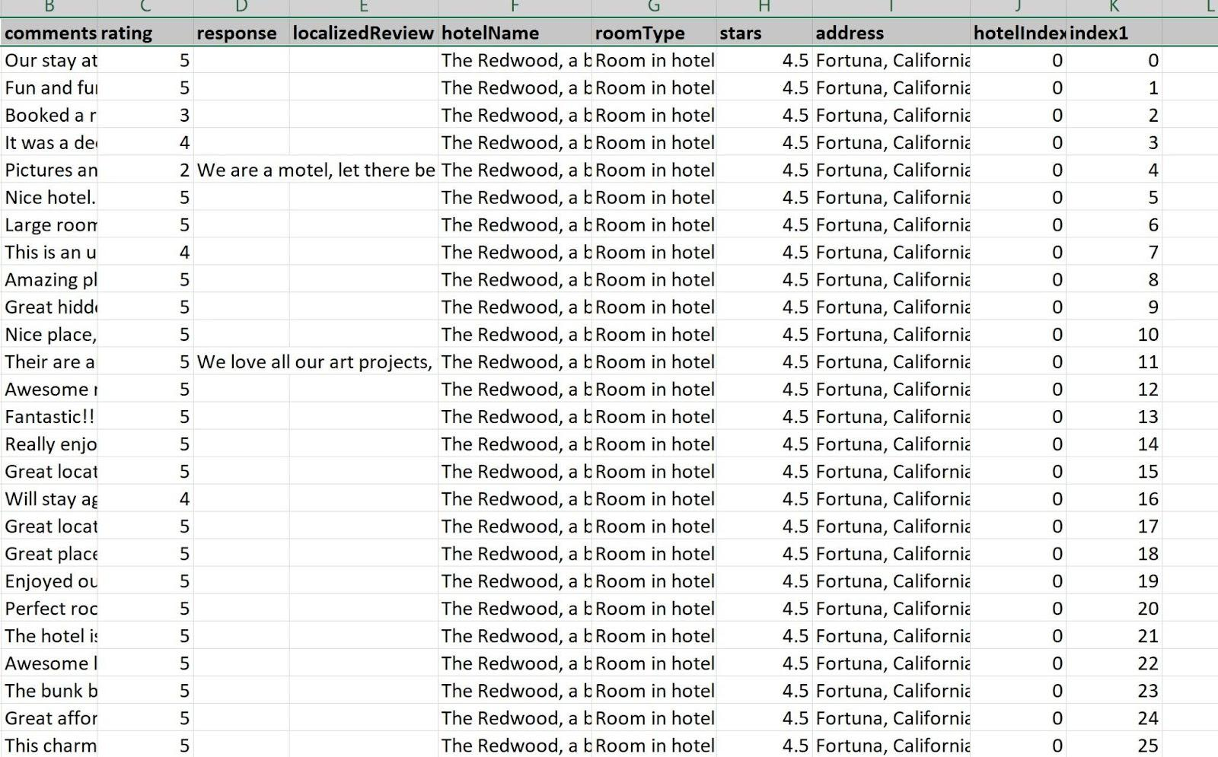

Further, Dataset was inconsistent when opened as a csv file. But after opening as a JSON file format. The Data Frame could read the data in a consistent manner. Below is the information after using the JSON file.

Figure 4 shows the information about the dataset.

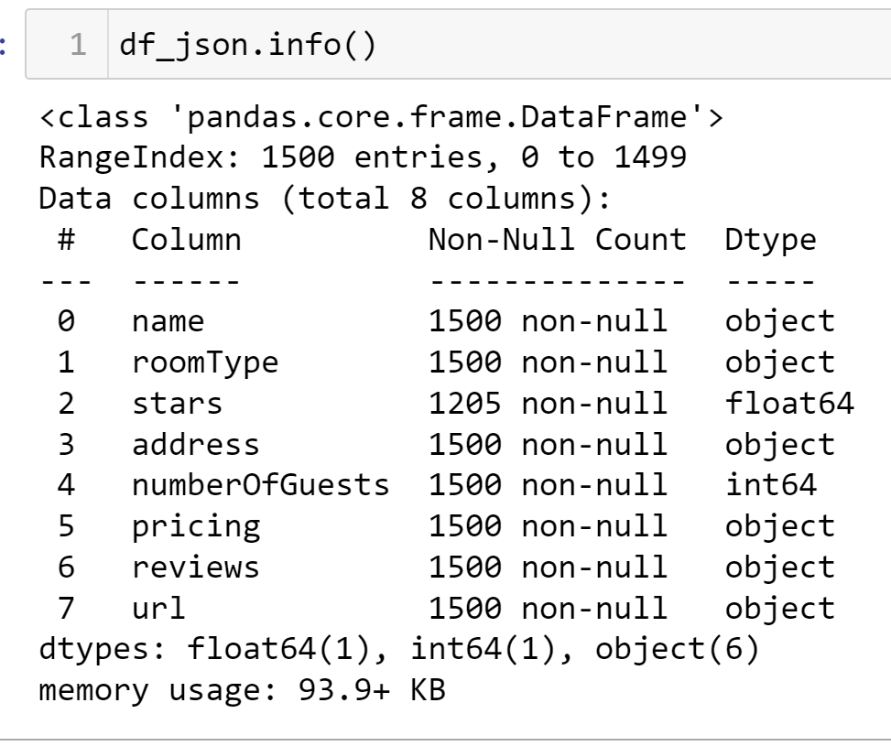

*Figure 4. Data Types and Null Values for Airbnb Raw Data*

**Basic EDA done for the extracted data:**

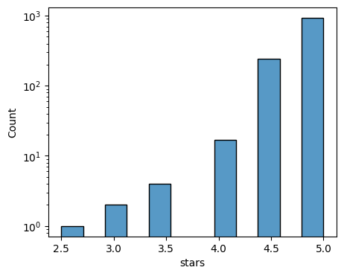

Hotels star rating was highly biased with the majority getting 5 star rating and rest were the outliers.

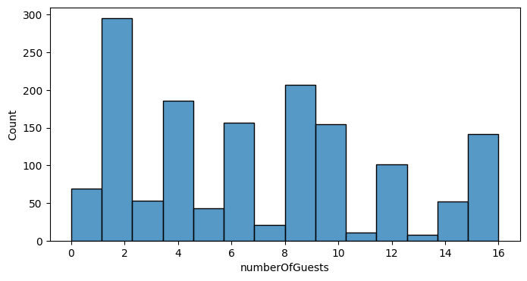

Most of the accompanying guests were two in number.

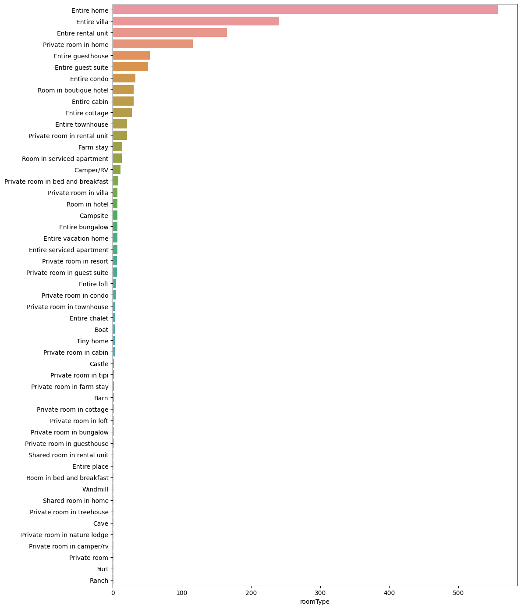

Most of the properties that were in demand were entire homes and villas.

These Features were not used in sentiment analysis but they can provide some feedback to Airbnb about what type of properties customers like and how many guests usually book so that in future such properties need to be of focus to gain more profits. But we will remove these columns for our sentiment analysis.

The review column was in a JSON file format itself so it had to be extracted and irrelevant columns were removed and the Dataframe was made by combining essential features of both the DataFrames.

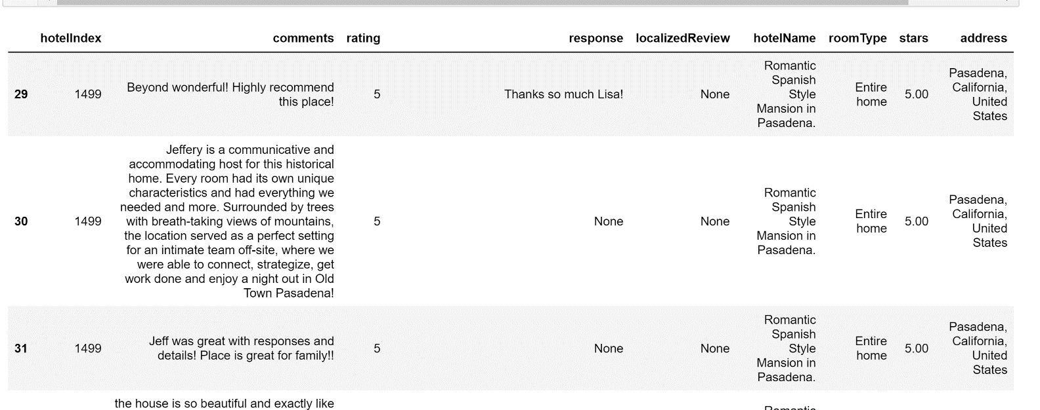

Figure 5 shows the merged DataFrame of reviews and parent hotel information containing those reviews.

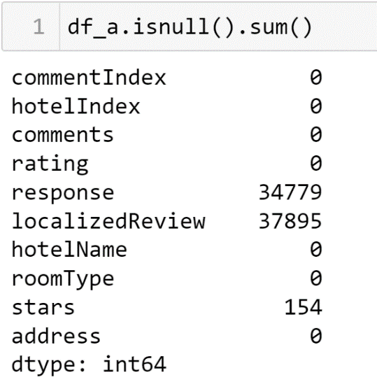

Figure 6: Checking for Null values in the DataFrame

As can be seen, there are three columns with Null Values. Investing each shows that response is the response by the hotel management to the review. So, we will not need this column for customer review analysis.

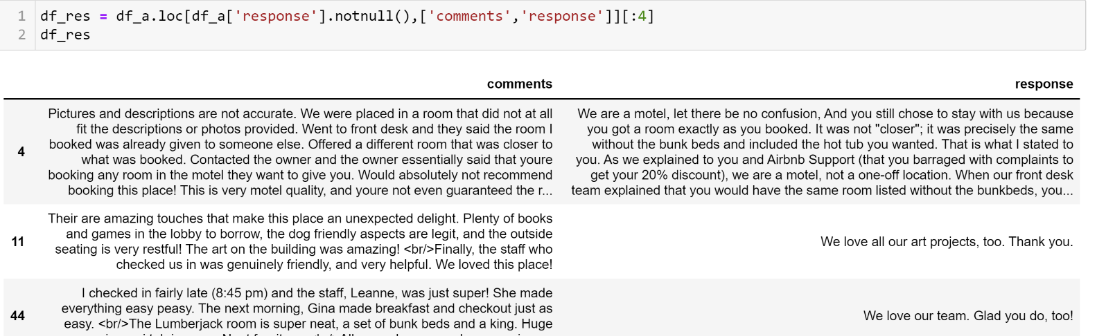

Figure 7 : Response column containing response by hotel. This column is not needed.

Second Null containing column is LocalizedReview. After looking into this column, it is a dictionary which contains the English translation of the comments/reviews given in vernacular language. This column is important and comment from the dictionary is extracted and regional comments are replaced with their respective English translation. After replacing the regional comments to English, this column is dropped.

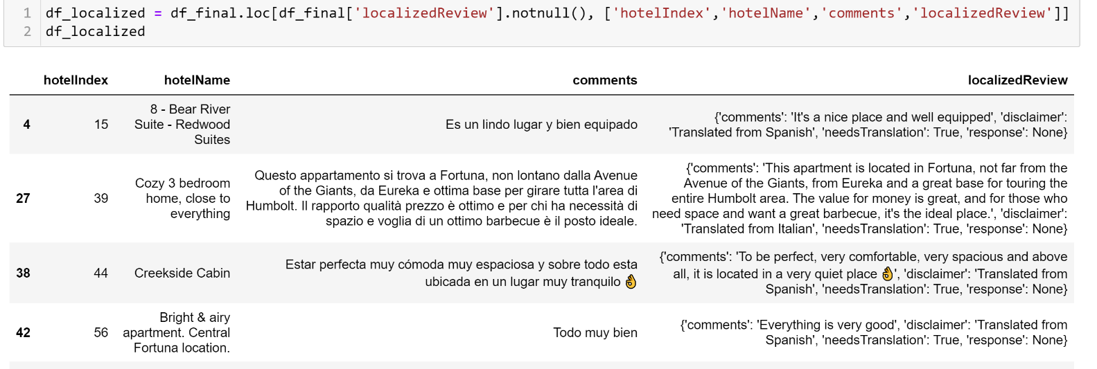

Figure 8: Comments in Regional Language

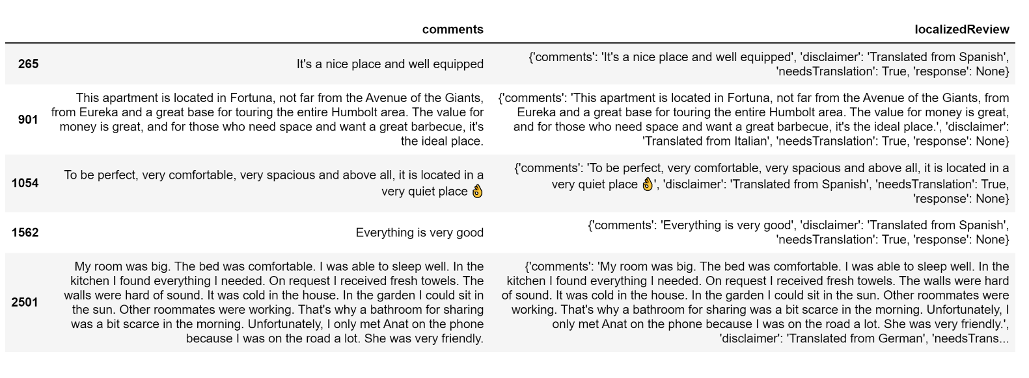

Figure 9: Regional Comments are converted into English

Since we are not using stars for the Hotel for sentiment Analysis, we will keep the column values as is.

**DATALABELLING**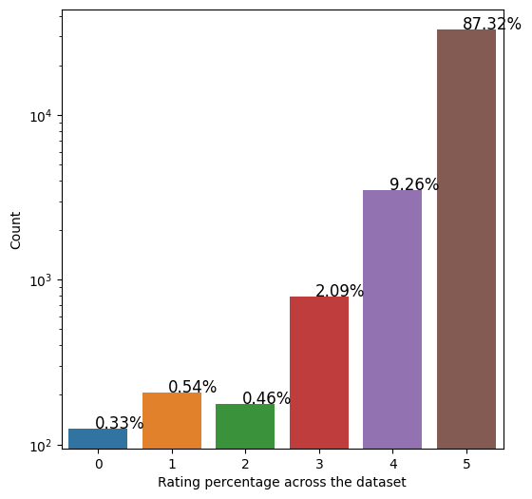

*Figure 8 : The ratings given to the reviews. Highly Biased with majority reviews getting 5 ratings.*

As can be seen from Figure 8, the dataset is highly biased with the majority 97% reviews getting ratings of 4 and 5 respectively in the dataset. Dataset is divided into positive and negative sentiments with positive sentiment(1) as rating 4 and 5 and negative sentiments(0) for ratings less than 4.

df_a['senti_rating'] = np.where(((df_a['rating'] == 5)|(df_a['rating'] == 4)),"Positive","Negative")

df_a['label'] = np.where(df_a['senti_rating']=='Positive',1,0)

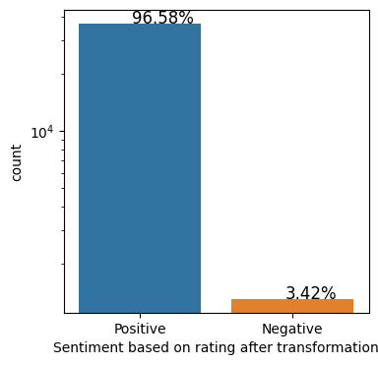

*Figure 9. Ratio of both the sentiments in the Dataset*

Figure 9 is the barchart showing the distribution of Positive and Negative Sentiments. The imbalance in the dataset might affect the performance of the models later and therefore, it needs to be treated. We will take a look at the sampling technique that we have used to augment the data to handle this imbalance.

**DATA CLEANING -NLP Models**

For sentiment analysis, the models that are used to classify the text need clean data. For NLP models, cleaning need to be minimal so that maximum intensity, polarity and sensitivity is captured. But for machine learning models, the data has to be cleaned enough using tokenization ,removal of stopwords and Lemmatization. For NLP models, the dataset is cleaned by removing HTML tags , Multiple spaces, numbers etc.

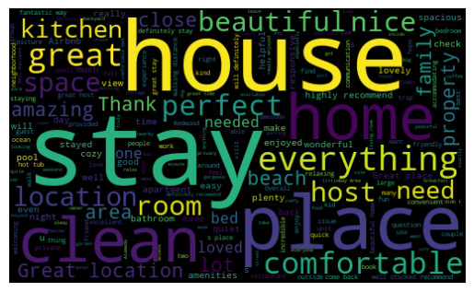

Figure 10: WordCloud after basic cleaning for NLP models

**DATA CLEANING - ML Models**

CountVectorizer and TF_IDF require texts to be cleaned from all HTML tags, punctuations, digits, multiple spaces, removal of stopwords that are predefined, converted into base lemma (meaningful root word) through lemmatization using parts of speech. After basic cleaning another column was created to process comments for further cleaning required by countVectorizer and TF-IDF vectorizer to convert each word into vector appropriately for Machine Learning models to use effectively.

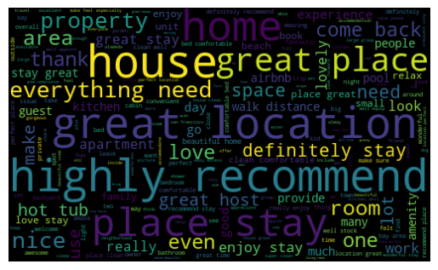

Figure 11: WordCloud after tokenization ,stopword removal and Lemmatization

**Number of Words and Number of Characters per review:**

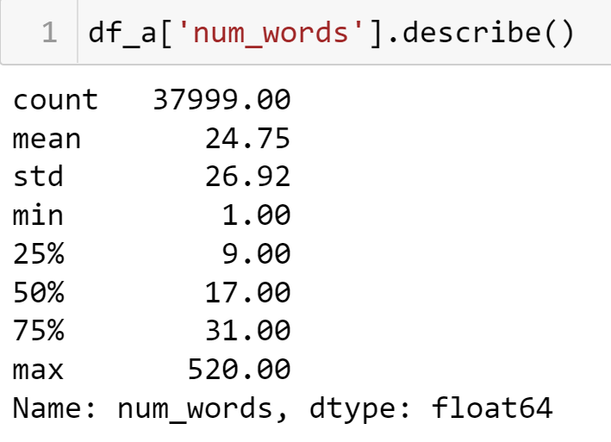 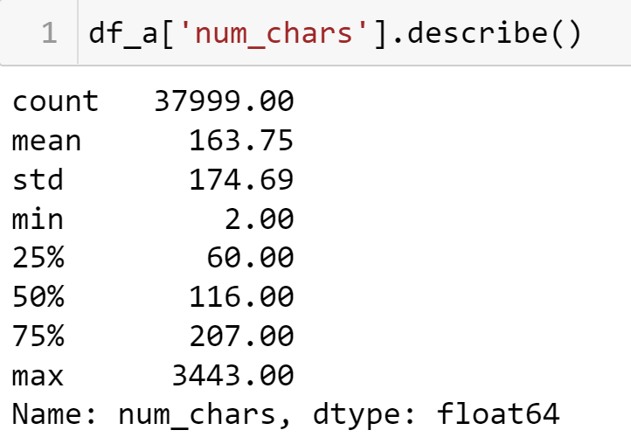

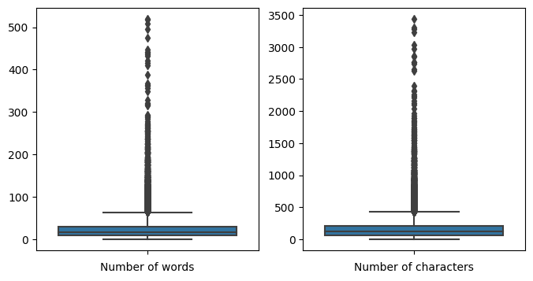

Figure 12: showing distribution of words and characters in a review

Maximum word count Review has 520 words with 31 and greater length word reviews are outliers.

Investigating more into it shows the interesting fact that among outliers there are more negative sentiments than positive.

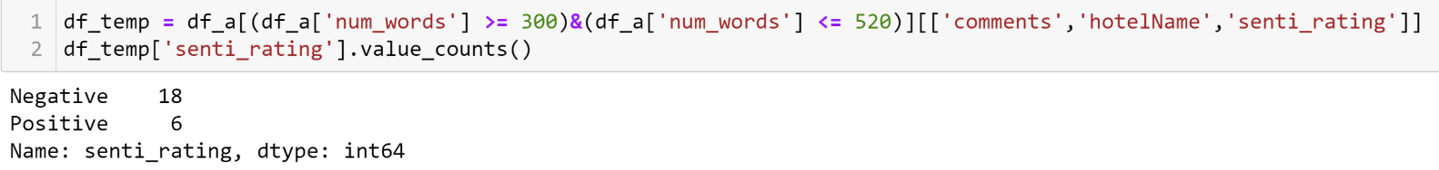

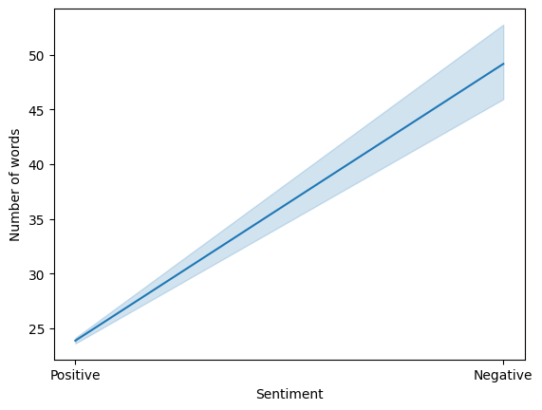

Figure 13: Showing As words increases negative sentiment increases

Further, where we have just two characters in a review, it shows different emotions for the same review through rating. Therefore, rating along with review is a good indicator to check the sentiment and that is why we labeled according to the rating.

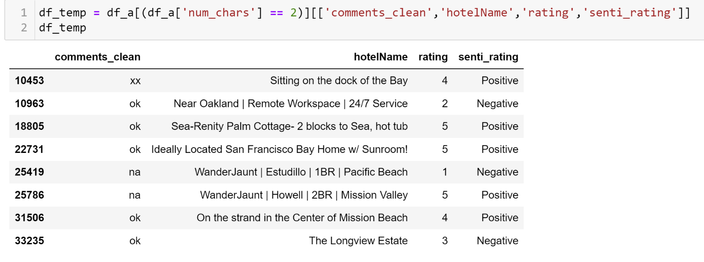

Figure 14: Two-character words showing same comment but different sentiment based on rating.

**DATA AUGMENTATION**

As mentioned above, the data is highly biased. So, we need sampling techniques to make the dataset more balanced. Different Sampling methods such as OverSampling and UnderSampling were considered. Since, we did not want to lose our data, we decided to go for over sampling methods such as Data augmentation and SMOTE. But for NLP purposes data augmentation seemed to be a better option.

We first segregated negative and positive comments and augmented the negative comments to the scale of the positive comments. Data augmentation works on the principle of creating text based on the different synonyms of the text provided to it. We used Data Augmentation – synonym augmentation library provided by NLTK package for this purpose.

Negative comments and positive comments were then merged together to form another DataFrame. It was shuffled and index was reset to build an unbiased DataFrame containing equal distribution of negative and positive sentiments.

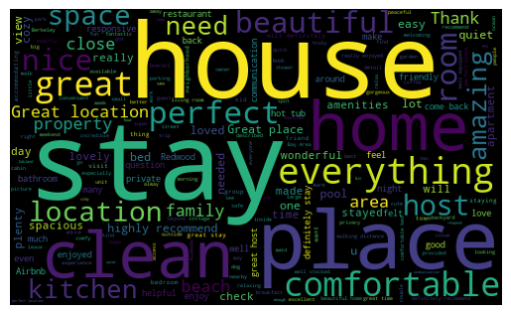

Figure 15: WordCloud of Positive comments

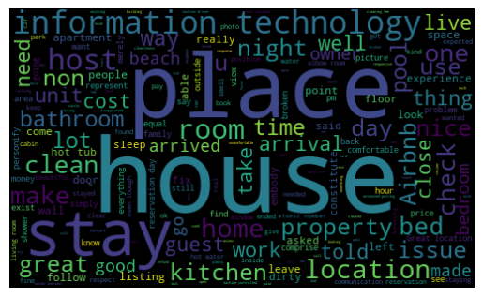

Figure 16: WordCloud of Negative comments

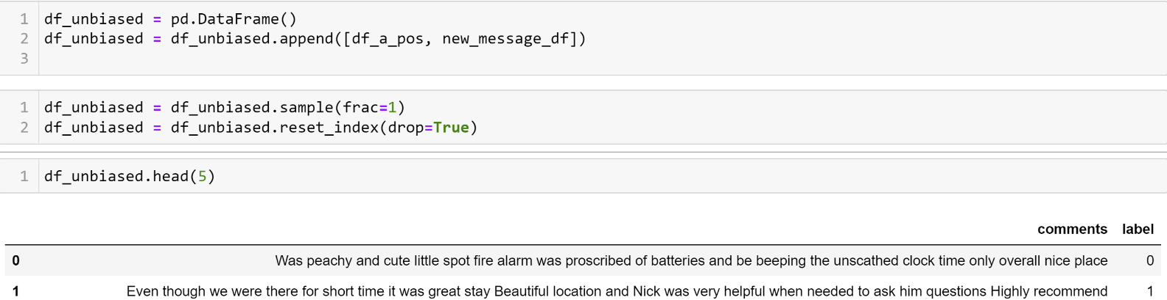

Figure 19: Unbiased DataFrame

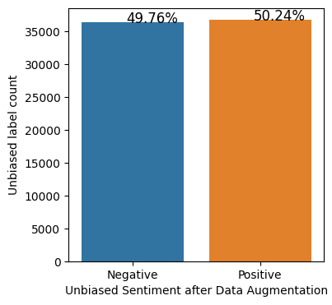

Figure 20: Bar chart showing proportion of Negative and Positive sentiments after Augmentation.

# MODEL TRAINING

### NLP MODELS

#### VADER:

Vader is a popular rule-based sentiment analyzer. It uses a list of lexical features (e.g., word) which are labeled as positive or negative according to their semantic orientation to calculate the text sentiment.

Vader sentiment returns the probability of a given input sentence to be Positive, Negative, and Neutral [0,1]. It also gives the compound score - overall sentiment [-1,1]. Vader outputs a dictionary like this: {'neg': 0.209, 'neu': 0.299, 'pos': 0.493, 'compound': 0.4404} wherein neg, neu and Pos are the probabilities of the sentiment. The sum of these three is always equal to 1.

The compound score is computed by summing the valence scores of each word in the lexicon, adjusted according to the rules, and then normalized to be between -1 (most extreme negative) and +1 (most extreme positive). This is the most useful metric if you want a single unidimensional measure of sentiment for a given sentence. It is often called as a 'normalized, weighted composite score'.

Basic clean comments are fed to Sentiment Analyzer of Vader. Two columns for probabilities and compound score are created. The vader sentiment column is created for classifying the comment with compound score > 0.5 as Positive(1) and compound score < 0.5 as Negative(0).

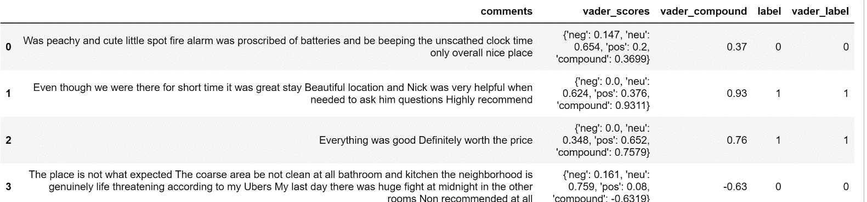

*Figure 21: Vader sentiment analysis of comments*

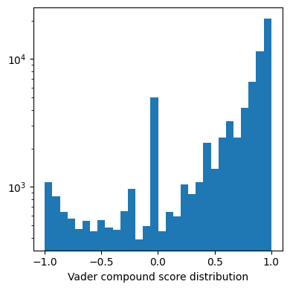

Figure 22: Vader compound Score Distribution

The overall distribution of compound score for our dataset looks similar to ratings with more propensity

towards positive sentiments.

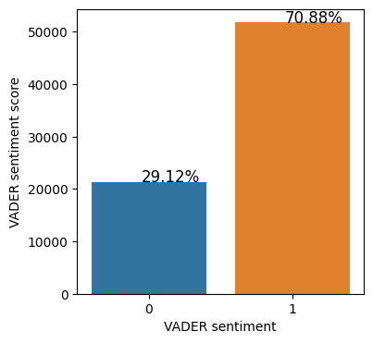 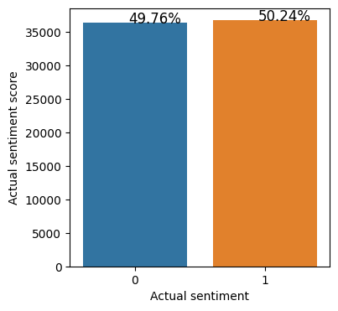

Figure 23: Vader Sentiment Distribution Figure 24: Actual Sentiment Distribution

**Vader Model Evaluation**

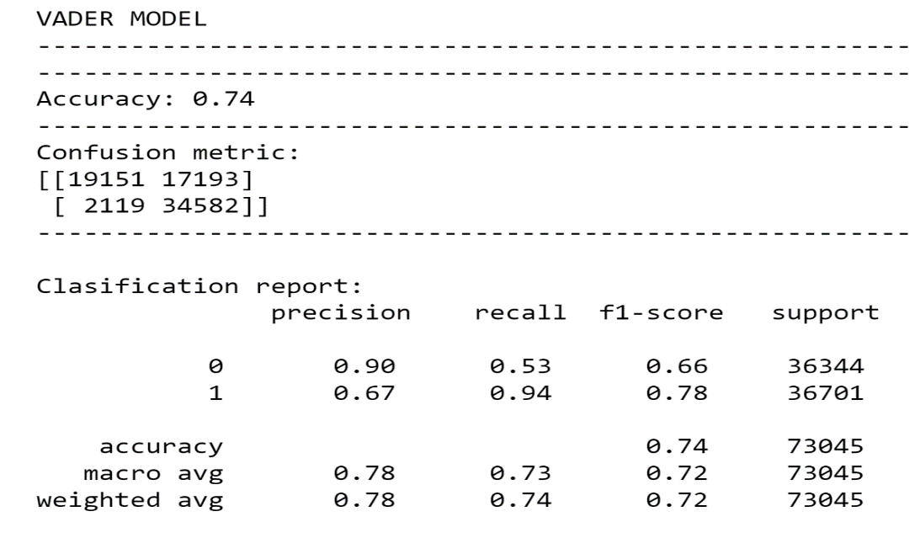

*Figure 25: Vader Performance metrics*

Vader Model took 0.877 minutes to run on the comments of entire Dataset of 73045 rows.

The model for the balanced Dataset gave 74% accuracy with 90% precision. That is, False Positives are way higher than False Negatives as recall is less. This may be used for recommendation systems as it will give users more positive sentiments. F1- score is not that great. Other models should be evaluated for further consideration.

TEXTBLOB:

Textblob is another Rule based sentiment Analyzer. It is a python library that offers API access to different NLP tasks such as sentiment analysis, spelling correction, etc. Textblob sentiment analyzer returns two properties for a given input sentence – Polarity and Subjectivity. Polarity is a float that lies between [-1,1], -1 indicates negative sentiment and +1 indicates positive sentiments. Subjectivity is also a float which lies in the range of [0,1]. Subjective sentences generally refer to personal opinion, emotion, or judgment. The higher subjectivity refers to the personal opinion as opposed to the facts.

Basic Clean comments when processed by TextBlob Analyzer, are returned with two values for which two columns are created. Textblob subjectivity tells how subjective is the statement. We use TextBlob Polarity to classify our reviews. Reviews with Polarity greater than 0.5 are considered Positive(1) and Reviews with Polarity < 0.50 are considered as Negative(0).

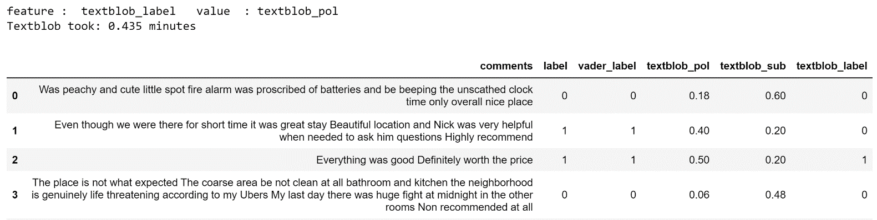

*Figure 26: TextBlob Sentiment Analysis of the comments*

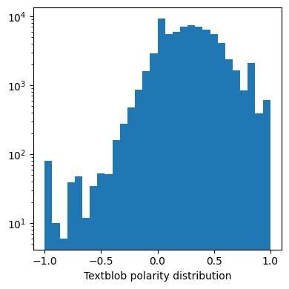

*Figure 27: TextBlob Polarity Distribution*

Overall polarity distribution looks left skewed with majority sentiments lying under 0.5 our threshold.

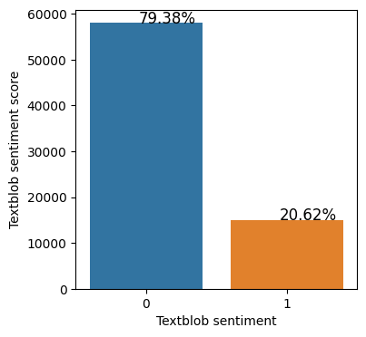 

*Figure 28 : TextBlob Sentiment Distribution vs Actual*

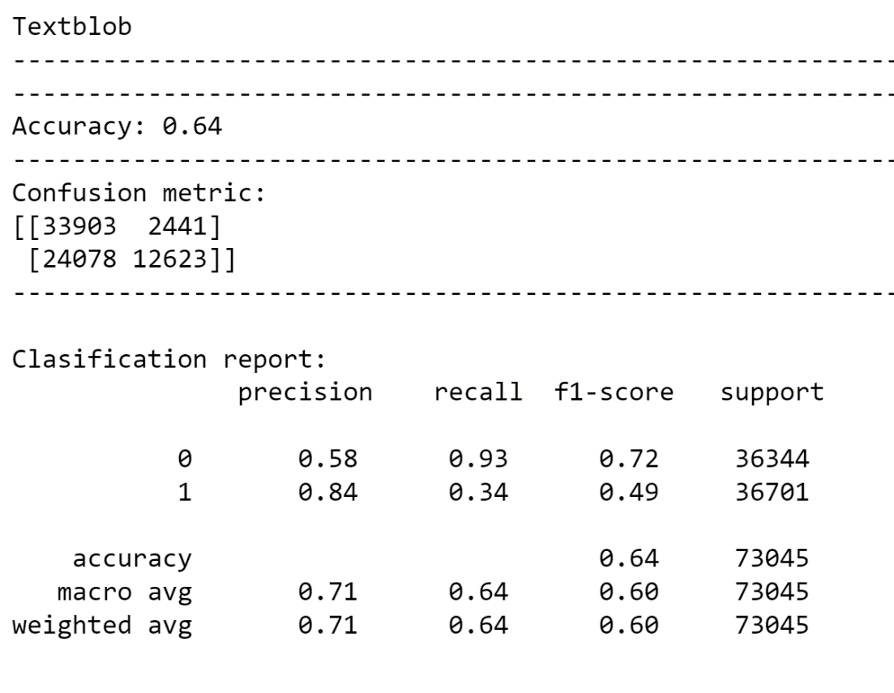

*Figure 30: TextBlob accuracy metrics*

TexBlob took 0.435 minutes to run for 73045 rows. Its accuracy of 64% is worse than Vader model with 74% accuracy. Here, the recall rate is very high. Therefore, False Negatives are more in this model. F1-score of less than 49% for positive sentiment is also not promising. Hence, it should not be used for recommendation system for our Dataset.

### FLAIR:

Flair is an Embedding based model built on Pytorch. Text embeddings are a form of word representation in NLP in which synonymically similar words are represented using similar vectors that means when represented in an n-dimensional space these vectors will be close to each other. Flair provides various functionalities such as pre-trained sentiment analysis models, text embeddings, NER, and more.

Flair returns the sentiment along with the confidence score ranging from 0 to 1, where 0 means very unconfident about the prediction and 1 means very confident about the prediction.

When basic clean comments were fed through Flair TextClassifier, it returns sentiment value along with the confidence about that sentiment. A new column is created to classify the reviews based on the sentiment returned.

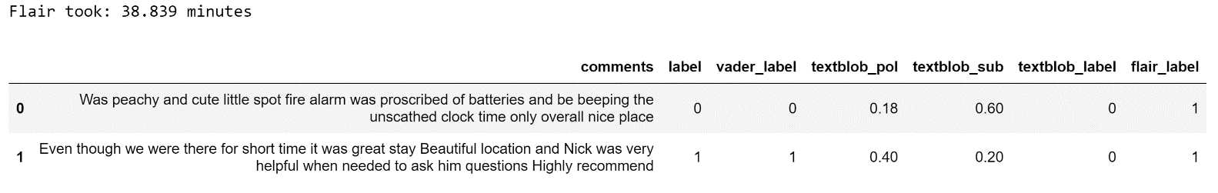

*Figure 31: Flair Sentiment Analysis*

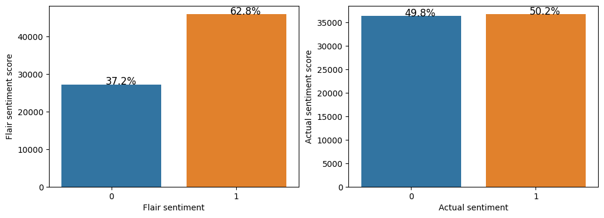

*Figure 32: Flair Sentiment Distribution*

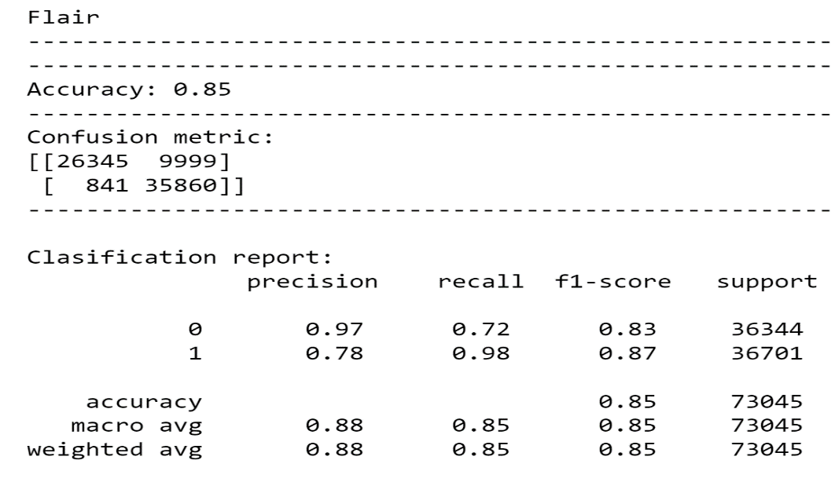

*Figure 33: flair accuracy metric*

Flair does a better proportion of negative and positive sentiments than TextBlob and Vader. It took 38.8 minutes to run total of 73045 rows. Here, the balanced set is giving a much better accuracy of 85% as opposed to Vader with 74% and TextBlob with 64%. F1-score that is harmonic mean, is also maintaining a good balance between precision and recall. Precision is higher than recall, with recall also having a better score than previous Models. This can be used for the recommendation system.

### NLP Model Comparison

If Accuracy is considered as a whole, then FLAIR Model gives better results of 38% than Vader with 33% and Textblob with 29%.

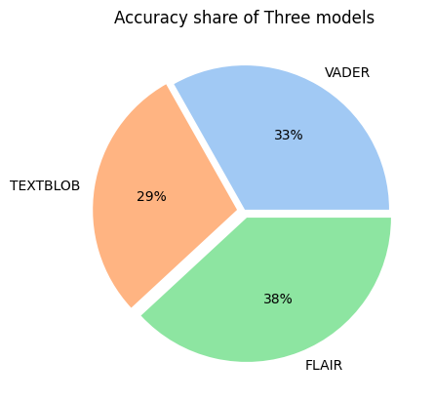

Figure 34: NLP Model Accuracy comparison as a whole

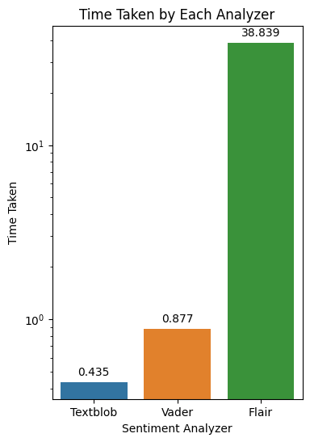

Figure 35: NLP Model execution time comparison

Model Prediction of Flair is the best but it takes a back seat when it comes to execution time. Flair took 38.839 minutes to complete execution. In fact, for all three models, there is a trade-off between accuracy and time execution. TextBlob performs best in terms of time execution but lags behind the other two in terms of accuracy.

**Machine Learning Model Training**

Since the text data cannot be directly used in machine learning and deep learning models we have used two statistical measures namely CountVectorizer and TF-IDF to transform a given text into a vector on the basis of the frequency (count) of each word that occurs in the entire text and importance of the those words.

Using the vectorized data we implemented 8 machine learning classification models (Logistic Regression, K-Nearest Neighbors, Decision Tree Classifier, Multinomial Naïve Bayes’, Bagging Classifier, Random Forest Classifier, XGBoost Classifier, ADABoost Classifier) out of which we will be displaying the top three performing models in each vectorizer.

Apart from the model’s accuracy being 99% we have used other evaluation metrics as well to better understand the performance of our classification model and verify it. Confusion Matrix is a tabular summary of the number of correct and incorrect predictions for checking the effectiveness of the models. By using TPR(True Positive Rate) and FPR(False Positive Rate), the ROC(Receiver Operating Characteristics) probability curve is plotted, which shows our classification model’s performance at all classification thresholds. AUC represents the degree or measure of separability. Higher the AUC, the better the model is at predicting 0 classes as 0 and 1 classes as 1. In order to achieve better understanding and analysis of our model and its performance we have considered other measures such as. Precision,. Recall (TPR, Sensitivity), F1-Score as we learnt in the ML class.

Briefly defining the terms, Recall: from all the positive classes, how many we predicted correctly.; Precision: from all the classes we have predicted as positive, how many are actually positive. F-measure: F-score helps to measure Recall and Precision at the same time. It uses Harmonic Mean in place of Arithmetic Mean by punishing the extreme values more.

The best three performing models in each vectorizer are shown below. As we can see that the true positive and true negative scores are higher and since the AUC is also higher the performance of the model Random Forest is better at distinguishing between the positive and negative classes. FP rate is a higher concern here when compared to FN, so the precision is a useful metric in this case. The precision in case of Tfidf vectorizer seems better compared to the countvec vectorizer for the random forest model.

**Random Forest Using CountVec Vectorizer**

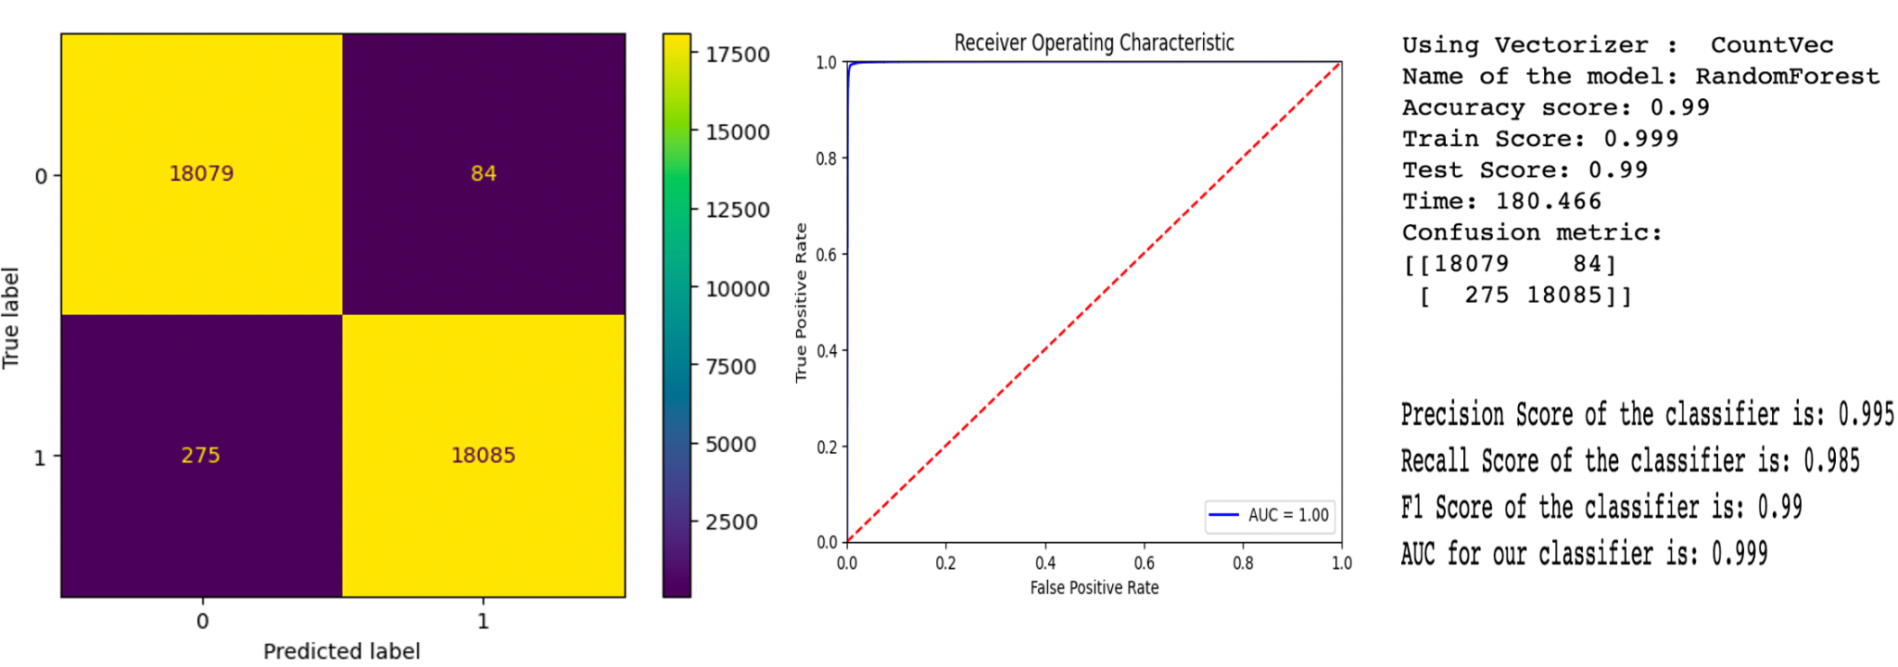

**Random Forest Using Tfidf Vectorizer**

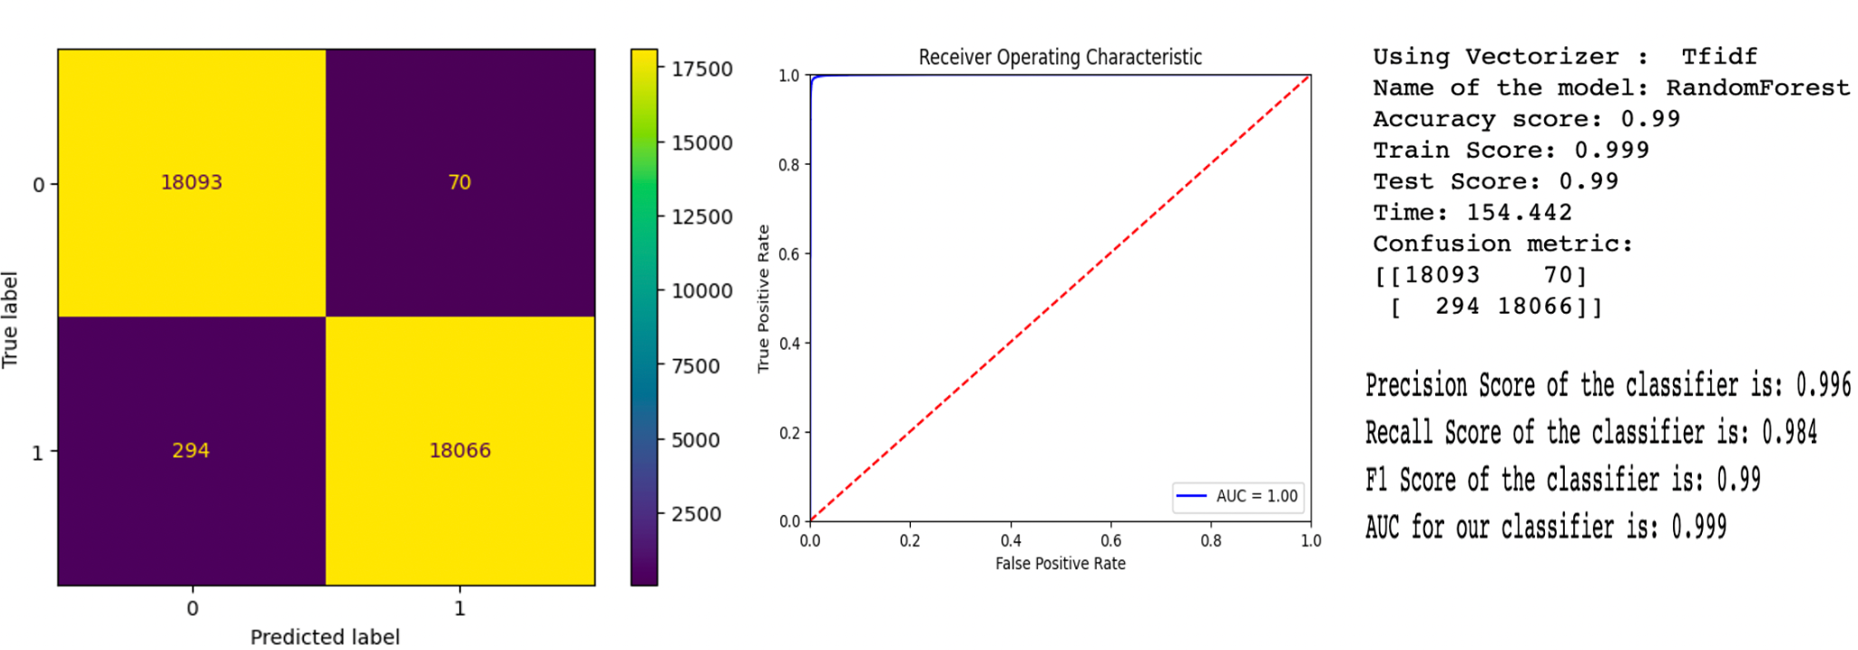

About the next best performing model, as we can see that the true positive and true negative scores are higher and since the AUC is also higher the performance of the model Logistic Regression is better at distinguishing between the positive and negative classes. FP rate is a higher concern here when compared to FN, so the precision is a useful metric in this case. The precision in case of countvec vectorizer seems slightly better compared to the Tfidf vectorizer for the logistic regression model.

**Logistic Regression Using CountVec Vectorizer**

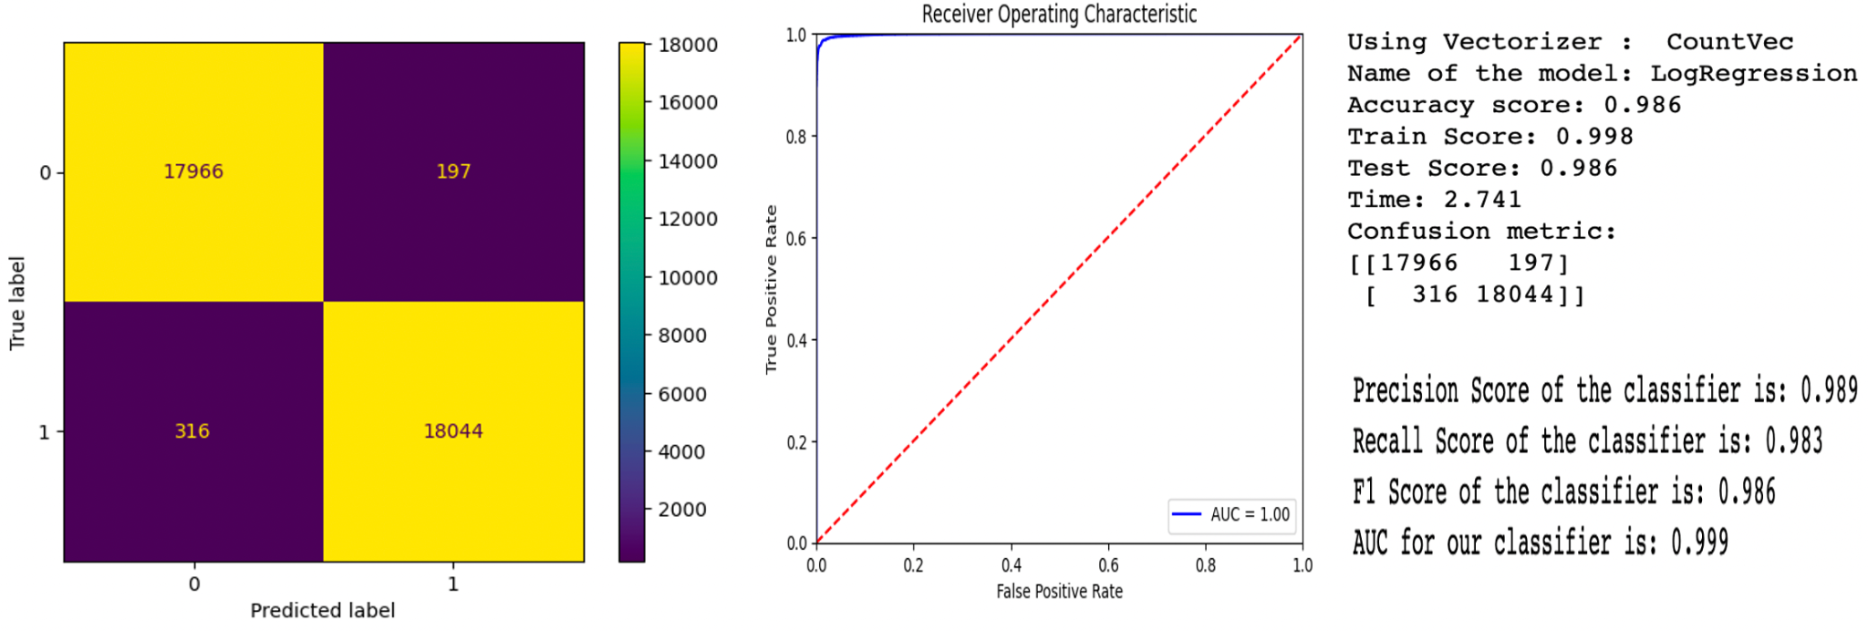

**Logistic Regression Using Tfidf Vectorizer**

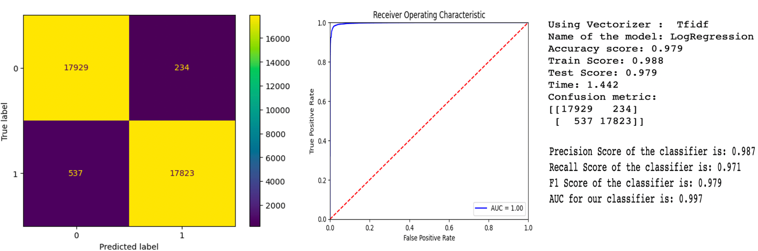

About the third next best performing model, as we can see that the true positive and true negative scores are higher and since the AUC is also higher the performance of the model Naive Bayes’ is better at distinguishing between the positive and negative classes. FN rate is a higher concern here when compared to FP, so the recall is a useful metric in this case. The recall in case of countvec vectorizer seems slightly better compared to the Tfidf vectorizer for the naive bayes’ model.

**Naive Bayes’ Model Using CountVec Vectorizer**

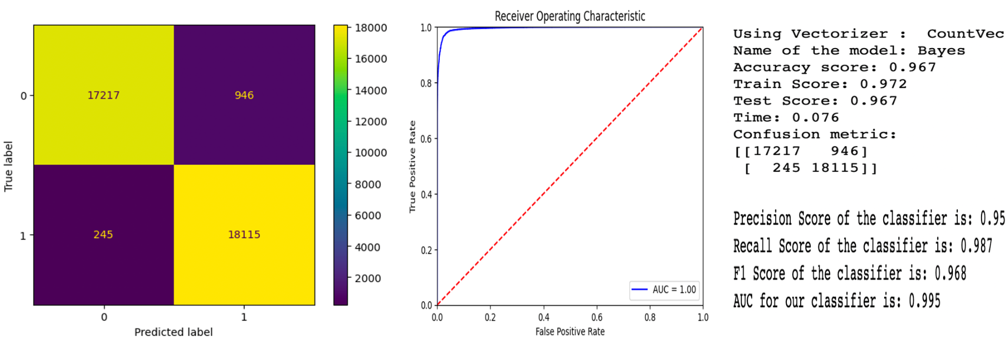

**Naive Bayes’ Model Using Tfidf Vectorizer**

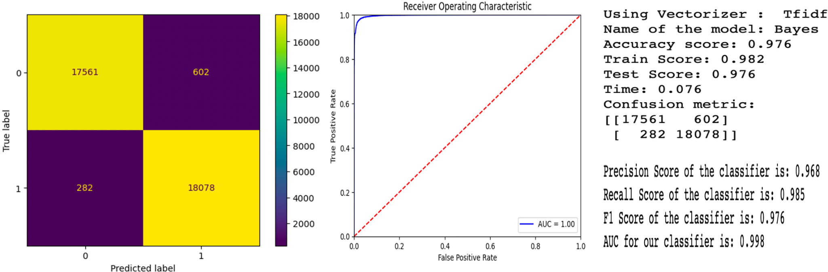

As a summary, we can see that the choice of algorithm can decide which vectorizer is working better. The below bar chart shows the comparison of the accuracy of all the models using both the vectorizers.

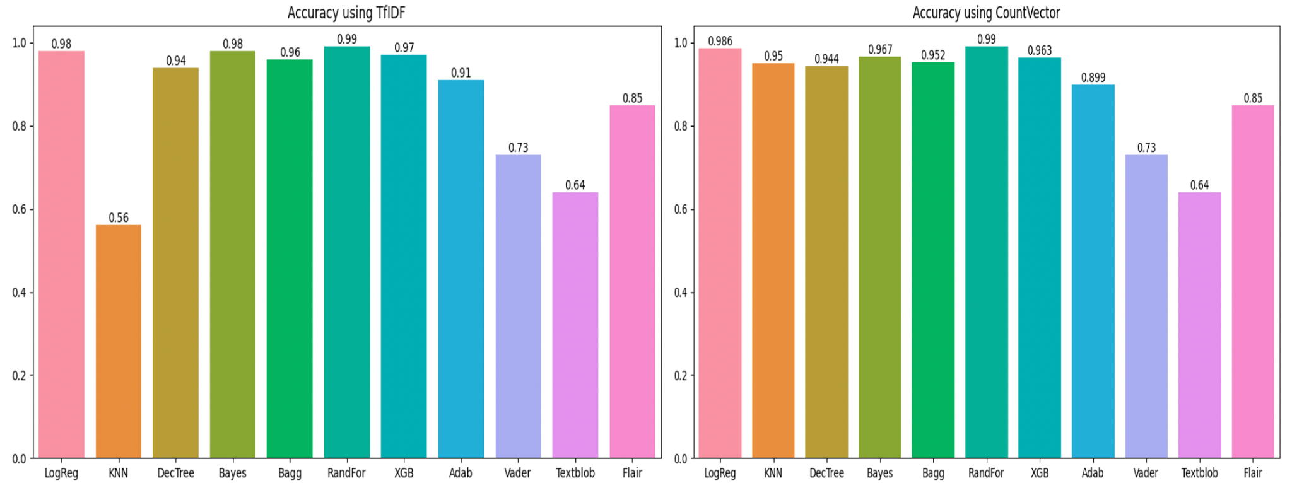

We then saved the ML model using Pickle by passing the model object into the dump() function of Pickle. This will serialize the object and convert it into a “byte stream,” which we saved as a file called model.pkl. Then we loaded the saved model from a Pickle file by passing the “pickled” model into the Pickle load() function, and it was deserialized by running our original model’s predict() function and we got back our array of predictions.





**7. Recommendation System**

Our project primarily focuses on two goals. The first step is to offer sentiment analysis of user-posted reviews on Airbnb. In order to help Airbnb improve hotels, this will assist in identifying potential positive features in a hotel as well as negative aspects of a hotel based on the review. The second goal is to create a system for users to receive hotel recommendations based on reviews left by other users who have stayed there.

After lemmatization, tokenization, and data augmentation processes, we removed the positive and negative review data from this model. The word clouds for both positive and negative reviews were then plotted, and this was how we analyzed the reviews.

**Word Cloud for Positive Reviews**

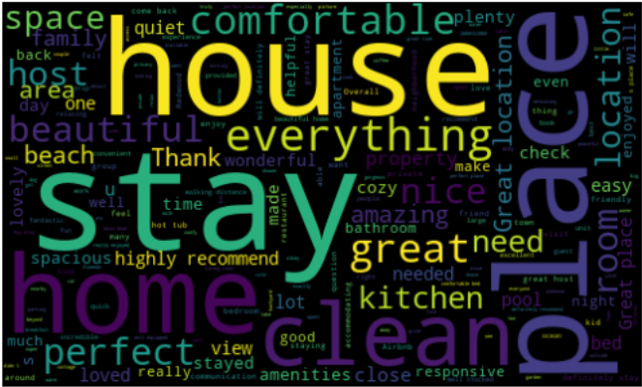

**Word Cloud for Negative Reviews**

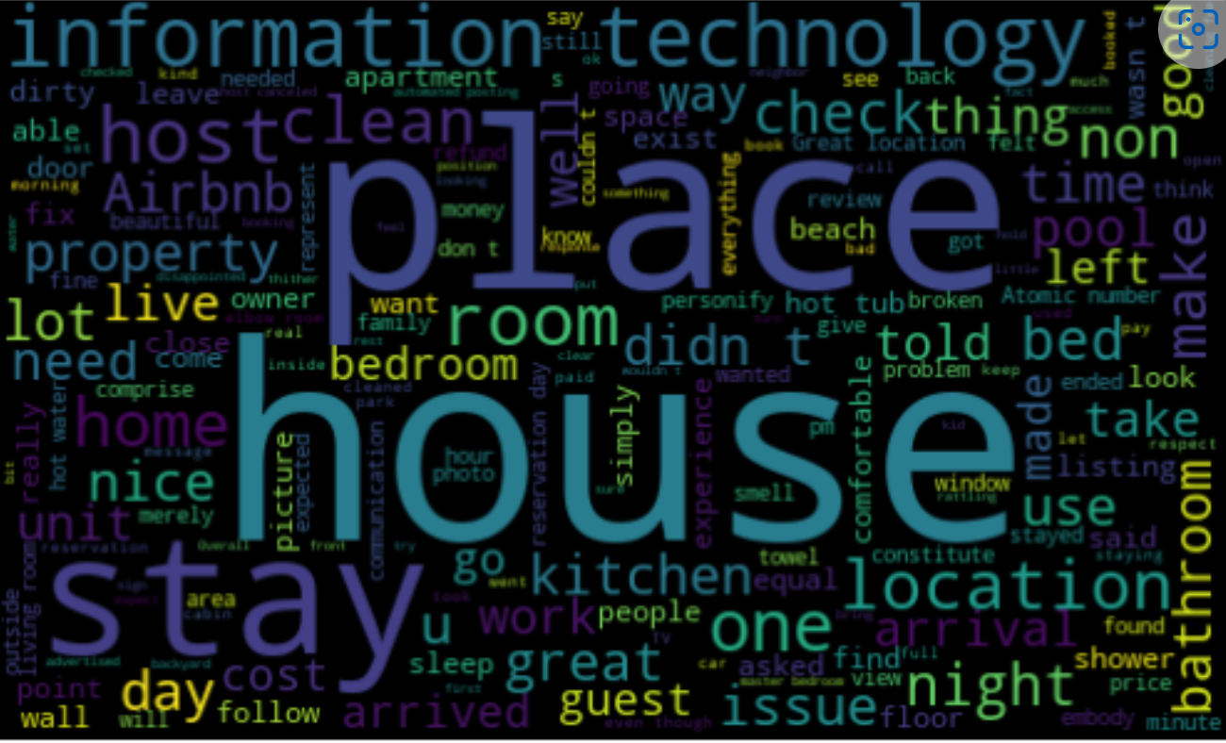

From the two figures above, it is clear that certain operational aspects of a hotel are frequently mentioned in both positive and negative sentiments. We have taken 20 hotel qualities from the word clouds above that we could offer to the user, which could assist the user in finding the best hotels for his use case.

**Different User Preferences provided to the user**

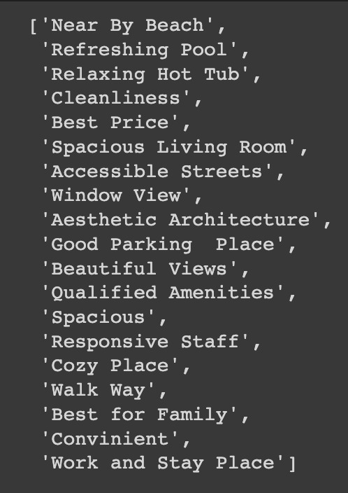

The user can choose to sort California hotels first by region or location. In California, we have more than 250 location options. The user has access to twenty different filtering options, where they can make a multiple-choice selection and receive the best hotels recommended based on their preferences.

After the user has submitted his information, including the city and his preferences, we will take those decisions into account. The data will first be filtered based on the location provided, and then vectorized so that each word in the comment is a separate column.

**Recommendation Algorithm**

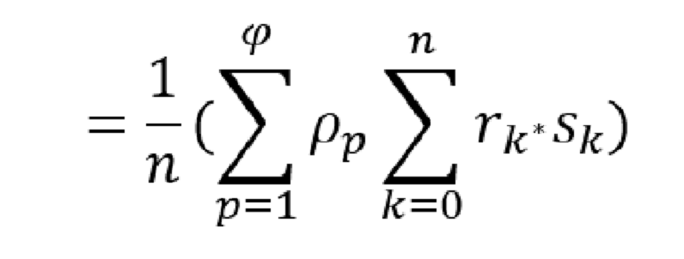

**Featured used for Recommendation System**

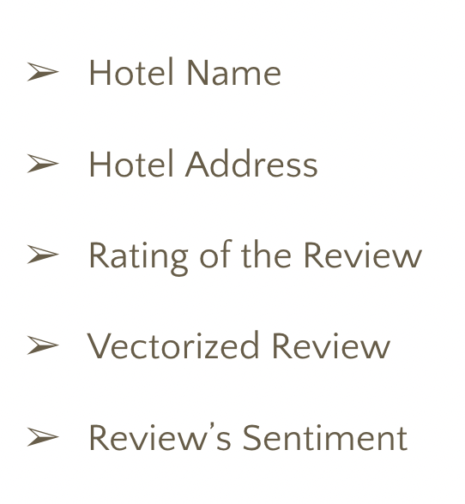

We have used the above features in our recommendation algorithm. We determine the word count for each comment and add them in accordance with the user's preferences (P). Then we multiply the rating of each comment (r) with the flair sentiment score (s). Each hotel's average score is determined, and the hotels are then arranged from highest to lowest by score. The user will then be given recommendations for the top-scoring hotels.

# Deployment

Using HTML, CSS, and Javascript, we developed the pickle file model and the recommendation algorithm before building a Flask application. We linked the pickle and the original Python script to the user interface using the Flask framework. We have created a user interface for our front-end development that incorporates both sentiment analysis and recommendation analysis functionalities.

**User Interface Home Page**

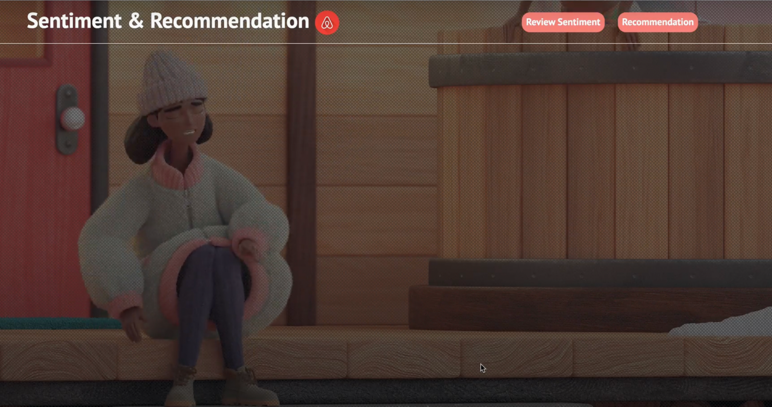

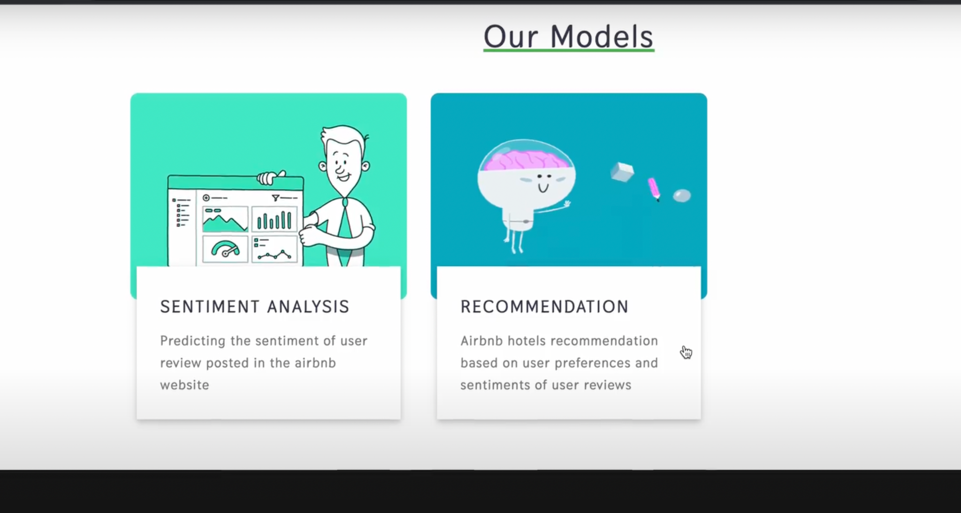

A homepage with a promotional video playing in the background and two buttons for sentiment analysis and a recommendation system make up the proposed and designed user interface. We can find the problem statement and a brief explanation of the two functionalities by scrolling down the same page.

**Sentiment Analysis GUI**

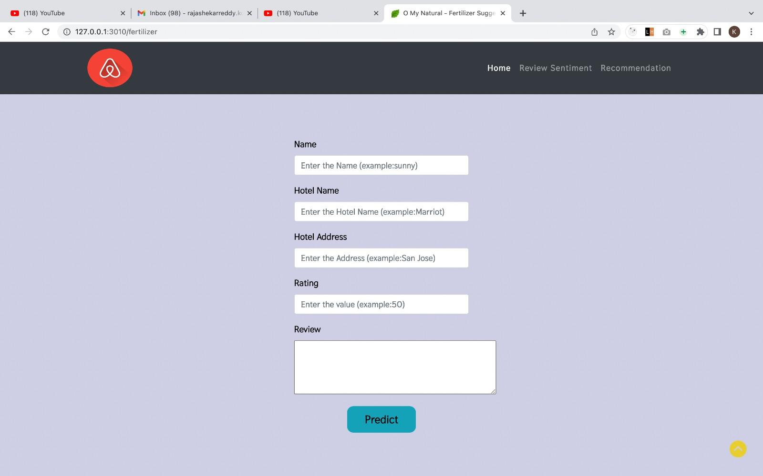

The user will be presented with options like name, hotel name, and address of the hotel where it is located in the sentiment analysis user interface, which is depicted in the figure above. For the current hotel, there is a rating field and a review field. The user can find a button indicating that the sentiment of the review will be predicted by parsing through the pickle file created above after entering all the necessary information.

**Recommendation System GUI**

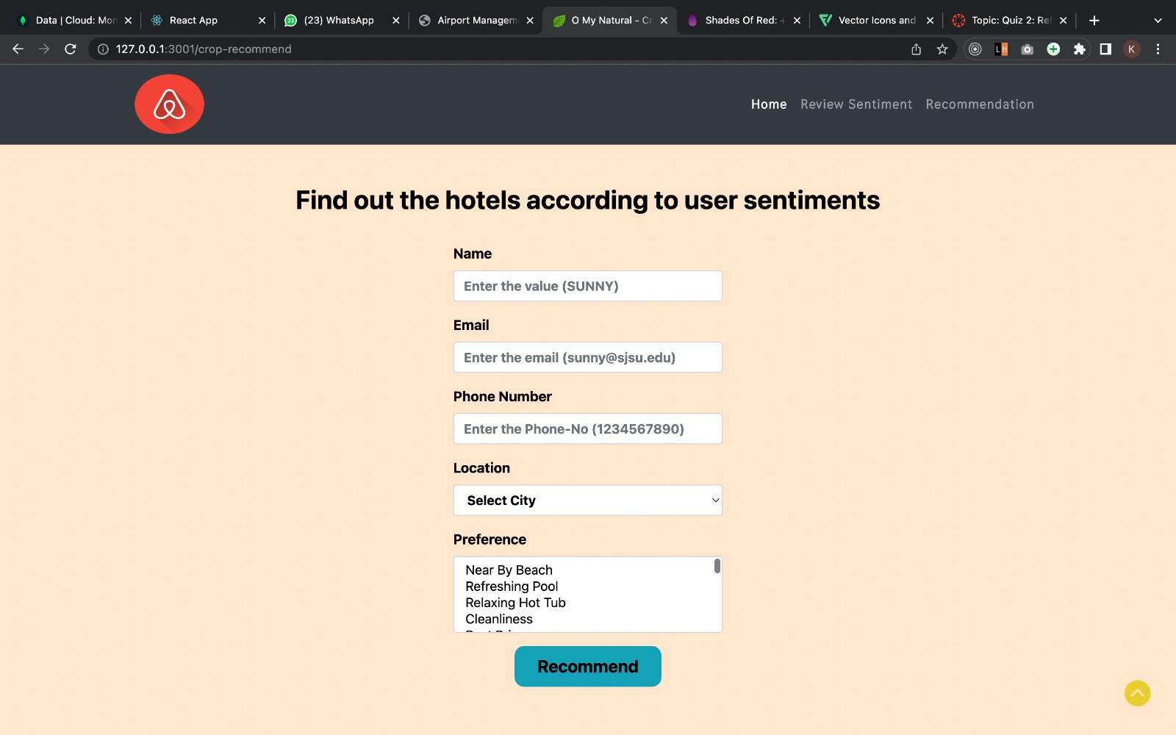

The project's recommendation system is its second feature, and it allows users to enter all relevant information, including the name of the reviewer, their email address, their phone number, and the city in which they are looking for AirBnB recommendations. Preferences will be the last box, a multiple-select box where the user can enter multiple preferences. We will list the top 10 hotels based on the developed recommendation algorithm.

For the deployment of our project, we used Amazon Web Services. We used an AWS EC2 instance to deploy the Flask application.

**10. Future Scope**

For better model building, we will take into account spam reviews as well as fake reviews. More user-friendly features, such as more filtering choices, locations, etc., will be added. The data from AirBnB is continuously integrated and deployed in order to train the model and keep it current. We'll consider every conceivable extreme case. It is planned to develop recommendation engines using some deep learning models. For a better recommendation to the user, take into consideration some edge case scenarios. development of a recommendation engine based on similar user’s preferences.

# References

Bridges, J. (2022, February 24). 20 stats about online reviews that hoteliers need to know. Reputation Defender. Retrieved November 22, 2022, from <https://www.reputationdefender.com/blog/online-reviews/20-stats-about-online-reviews-that-hoteliers-need-to-know>

Sharma, Y., Bhatt, J., &amp; Magon, R. (2015). A multi-criteria review-based hotel recommendation system. 2015 IEEE International Conference on Computer and Information Technology; Ubiquitous Computing and Communications; Dependable, Autonomic and Secure Computing; Pervasive Intelligence and Computing. https://doi.org/10.1109/cit/iucc/dasc/picom.2015.99

Bauman, K., Liu, B., &amp; Tuzhilin, A. (2017). Aspect based recommendations. Proceedings of the 23rd ACM SIGKDD International Conference on Knowledge Discovery and Data Mining. https://doi.org/10.1145/3097983.3098170

Fang, X., &amp; Zhan, J. (2015). Sentiment analysis using product review data. Journal of Big Data, 2(1). https://doi.org/10.1186/s40537-015-0015-2

Hu, Ya-Han; Lee, Pei-Ju; Chen, Kuanchin; Tarn, J. Michael; and Dang, Duyen-Vi, (2016). HOTEL RECOMMENDATION SYSTEM BASED ON REVIEW AND CONTEXT INFORMATION: A COLLABORATIVE FILTERING APPRO. PACIS 2016 Proceedings. 221.